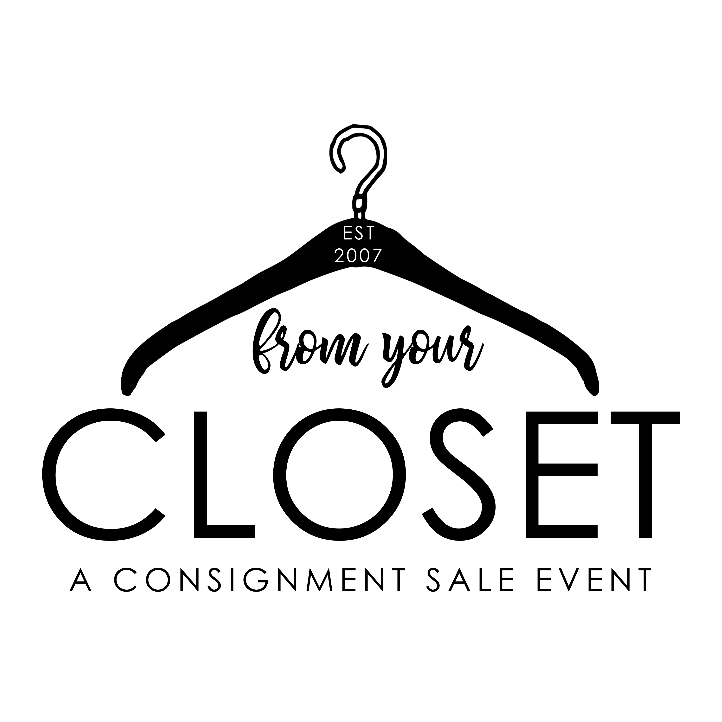

FYCC Tagging Service

Thank you for using our Tagging Service. We are happy to offer this to consignors. Please read the following guidelines and sign at the bottom to acknowledge and agree to all conditions.

Consignor will:
- Prepare items as listed on www.fromyourcloset417.com.
- Bring only season appropriate clothing sorted by gender.
- Understand that you will receive 50% of their sales.
- Pick up unsold merchandise that is not donated at the designated pick up time.
- Understand that FYCC will price the item as they wish and by participating in the tagging service, each consignor waives the right to price their own items.

Consignor Name: ____________________________________
Consignor Signature: __________________________________
Consignor Number: ___________________________________
Date: _______________________________________________

Do you want your items discounted? YES or NO

Do you want your items donated? YES or NO

If your items are NOT donated, it is your responsibility to pick up the unsold merchandise during the scheduled pick up day/time. If you do not pick up, your items will be donated.

